**PIR, Temperature sensors and buzzers**

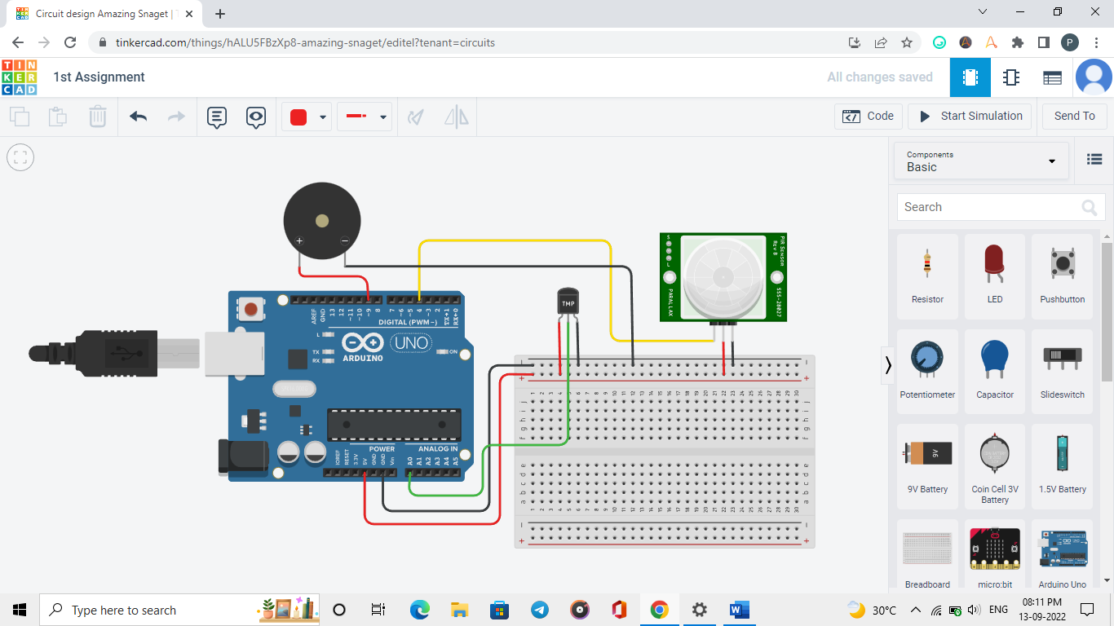

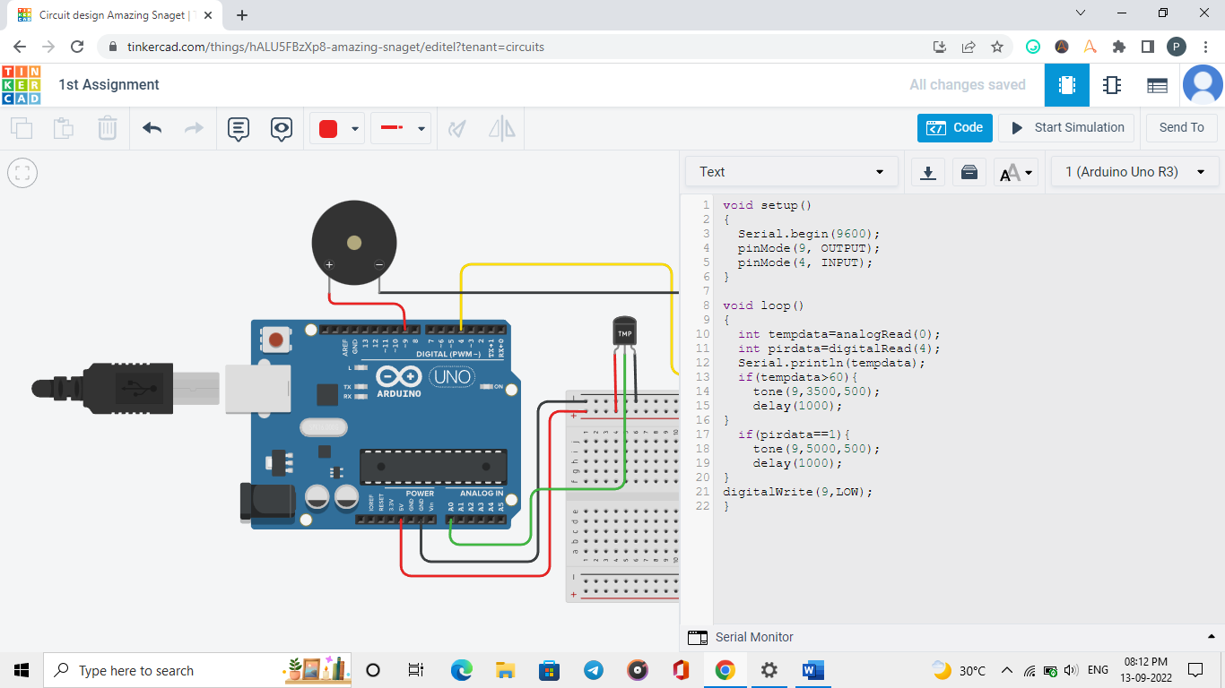

Code:

void setup()

{

Serial.begin(9600);

pinMode(9, OUTPUT);

pinMode(4, INPUT);

}

void loop()

{

int tempdata=analogRead(0);

int pirdata=digitalRead(4);

Serial.println(tempdata);

if(tempdata>60){

tone(9,3500,500);

delay(1000);

}

if(pirdata==1){

tone(9,5000,500);

delay(1000);

}

digitalWrite(9,LOW);

}